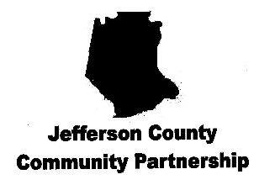
Notifying the Public of Rights Under Title VI
Jefferson County Community Partnership (JCCP) operates its programs and services without regard to race, color and national origin in accordance with Title VI of the Civil Rights Act.
To obtain additional information about your rights under Title VI, contact Jefferson County Community Partnership.
Any person who believes he or she has been aggrieved by an unlawful, discriminatory practice under Title VI may file a complaint with JCCP.
For more information on the JCCP civil rights program or to file a complaint, contact:

Phone: 636-465-0983
Email: partnership@jccp.org
Mail or in person: 3875 Plass Road, Building A, Festus, MO 63028
You may also visit our website at www.jccp.org

In addition to the complaint process at JCCP, complaints may be filed directly with the Federal Coordination and Compliance Section, Civil Rights Division, U.S. Department of Justice, 960 Pennsylvania Avenue, Washington, D.C. 20530.
Complaints must be filed within 180 days following the date of the alleged discriminatory occurrence and should contain as much detailed information about the alleged discrimination as possible.

